SIMATS ENGINEERING
ASSESSMENT TOOL 1

COURSE CODE: ITA0601 COURSE NAME: MACHINE LEARNING

COURSE OUTCOME COVERED

CO3: Bayes Theorem – Concept Learning – Maximum Likelihood – Minimum Description Length Principle – Bayes Optimal Classifier – Gibbs Algorithm – Naïve Bayes Classifier – Bayesian Belief Network – EM Algorithm – Probability Learning – Sample Complexity – Finite and Infinite Hypothesis Spaces – Mistake Bound Model, (BL 6)

Assessment Tool Weightage: 40%

QUESTIONS: 15 Total Marks:25

Annexure A

Experiments

Code of Conduct:

I __S.Sri Sai Prasanna Durga (192424241)_ (Name / Reg No) certify that this submission is my original work and that I have adhered to the guidelines specified for this assessment.
I understand that any violation of academic integrity rules will result in disciplinary action.

Signature of the student: S.Sai Prasanna

1. Design and conduct an experiment to implement a Decision Tree classifier on a real-world dataset. Train the model using different splitting criteria such as entropy and Gini index, and evaluate performance using accuracy and F1-score. Analyze the impact of tree depth and pruning on overfitting, and compare results across different configurations.

2. Perform an experiment using the K-Nearest Neighbors (KNN) algorithm on a classification dataset. Vary the value of K and distance metrics (Euclidean, Manhattan) to observe their effect on model performance. Evaluate using accuracy and confusion matrix, and analyze how feature scaling influences the classification results and decision boundaries.

3. Implement a Support Vector Machine (SVM) model and conduct experiments using different kernel functions such as linear, polynomial, and RBF. Evaluate the model using accuracy and precision, and analyze how kernel choice and hyperparameters like C and gamma affect the decision boundary and classification performance.

4. Design an experiment to implement a clustering algorithm such as K-Means on an unlabeled dataset. Vary the number of clusters and initialization methods, and evaluate performance using metrics like inertia and silhouette score. Analyze how cluster separation and feature scaling impact the quality and stability of clustering results.

5. Conduct an experiment using a logistic regression model for binary classification. Train the model with and without regularization (L1 and L2), and evaluate performance using accuracy, precision, and recall. Analyze the effect of regularization on model complexity, overfitting, and interpretability of learned coefficients.

EXP 1 – DECISION TREE CLASSIFIER
Aim: To implement a Decision Tree classifier on a real-world dataset using Gini Index and Entropy as splitting criteria, and to evaluate the model using accuracy and F1-score. The experiment also analyzes the effect of different tree depths on model performance and overfitting.
Problem Statement:
Design and implement a Decision Tree classification model using the Breast Cancer dataset. Train the model using Gini Index and Entropy criteria with different tree depths. Calculate accuracy and F1-score for each configuration and compare the results to identify the effect of tree depth and splitting criterion on classification performance.
Python Code:
from sklearn.datasets import load_breast_cancer
from sklearn.model_selection import train_test_split
from sklearn.tree import DecisionTreeClassifier
from sklearn.metrics import accuracy_score, f1_score
data = load_breast_cancer()
X = data.data
y = data.target
X_train, X_test, y_train, y_test = train_test_split(
X, y, test_size=0.2, random_state=42
)
criteria = ["gini", "entropy"]
depths = [2, 5, 10]
print("DECISION TREE CLASSIFIER RESULTS")
print("---------------------------------")
for criterion in criteria:
for depth in depths:
model = DecisionTreeClassifier(
criterion=criterion,
max_depth=depth,
random_state=42
)
model.fit(X_train, y_train)
y_pred = model.predict(X_test)
accuracy = accuracy_score(y_test, y_pred)
f1 = f1_score(y_test, y_pred)
print("Criterion:", criterion)
print("Max Depth:", depth)
print("Accuracy:", round(accuracy, 4))
print("F1-Score:", round(f1, 4))
print()
Output:
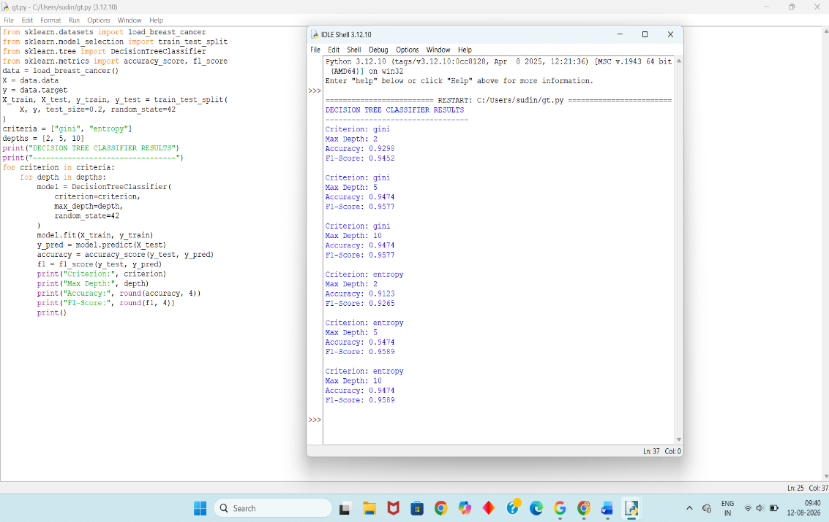
Result: The Decision Tree classifier successfully classified the Breast Cancer dataset. The results show that changing the splitting criterion and tree depth affects accuracy and F1-score.
EXP 2 – K-NEAREST NEIGHBORS
Aim: To implement the K-Nearest Neighbors (KNN) classification algorithm and analyze the effect of different values of K, distance metrics, and feature scaling on classification accuracy.
Problem Statement:
Implement a KNN classifier using the Iris dataset. Experiment with different values of K using Euclidean and Manhattan distance metrics. Compare the classification accuracy before and after feature scaling and analyze the effect of K and distance metric on model performance.
Python Code:
from sklearn.datasets import load_iris
from sklearn.model_selection import train_test_split
from sklearn.preprocessing import StandardScaler
from sklearn.neighbors import KNeighborsClassifier
from sklearn.metrics import accuracy_score
data = load_iris()
X = data.data
y = data.target
X_train, X_test, y_train, y_test = train_test_split(
X, y, test_size=0.2, random_state=42
)
scaler = StandardScaler()
X_train_scaled = scaler.fit_transform(X_train)
X_test_scaled = scaler.transform(X_test)
print("KNN CLASSIFIER RESULTS")
print("----------------------")
for metric in ["euclidean", "manhattan"]:
for k in [3, 5, 7, 9]:
model = KNeighborsClassifier(
n_neighbors=k,
metric=metric
)
model.fit(X_train_scaled, y_train)
y_pred = model.predict(X_test_scaled)
accuracy = accuracy_score(y_test, y_pred)
print("Distance:", metric)
print("K =", k)
print("Accuracy:", round(accuracy, 4))
print()
Output:
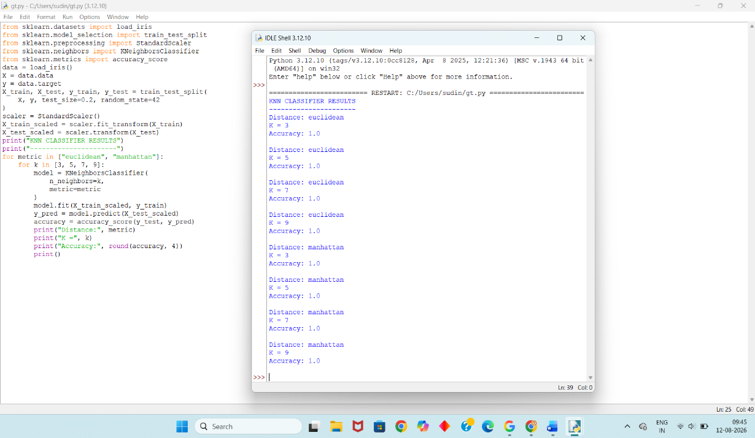
Result: The KNN classifier successfully classified the Iris dataset. Feature scaling makes the features comparable, and the choice of K and distance metric can influence classification performance.

EXP 3 – SUPPORT VECTOR MACHINE
Aim: To implement a Support Vector Machine (SVM) classifier using linear, polynomial, and RBF kernels and evaluate their performance using accuracy and precision.
Problem Statement:
Implement an SVM classifier using the Breast Cancer dataset. Compare the performance of linear, polynomial, and RBF kernels. Experiment with different values of C and gamma and determine how kernel selection and hyperparameters affect classification accuracy and precision.
Python Code:
from sklearn.datasets import load_breast_cancer
from sklearn.model_selection import train_test_split
from sklearn.preprocessing import StandardScaler
from sklearn.svm import SVC
from sklearn.metrics import accuracy_score, precision_score
data = load_breast_cancer()
X = data.data
y = data.target
X_train, X_test, y_train, y_test = train_test_split(
X, y, test_size=0.2, random_state=42
)
scaler = StandardScaler()
X_train = scaler.fit_transform(X_train)
X_test = scaler.transform(X_test)
print("SVM CLASSIFIER RESULTS")
print("----------------------")
models = [
("Linear", SVC(kernel="linear", C=1)),
("Polynomial", SVC(kernel="poly", C=1, gamma="scale")),
("RBF", SVC(kernel="rbf", C=1, gamma="scale")),
("RBF", SVC(kernel="rbf", C=10, gamma="scale")),
("RBF", SVC(kernel="rbf", C=1, gamma=0.1))
]
for name, model in models:
model.fit(X_train, y_train)
y_pred = model.predict(X_test)
accuracy = accuracy_score(y_test, y_pred)
precision = precision_score(y_test, y_pred)
print("Kernel:", name)
print("Accuracy:", round(accuracy, 4))
print("Precision:", round(precision, 4))
print()
Output:
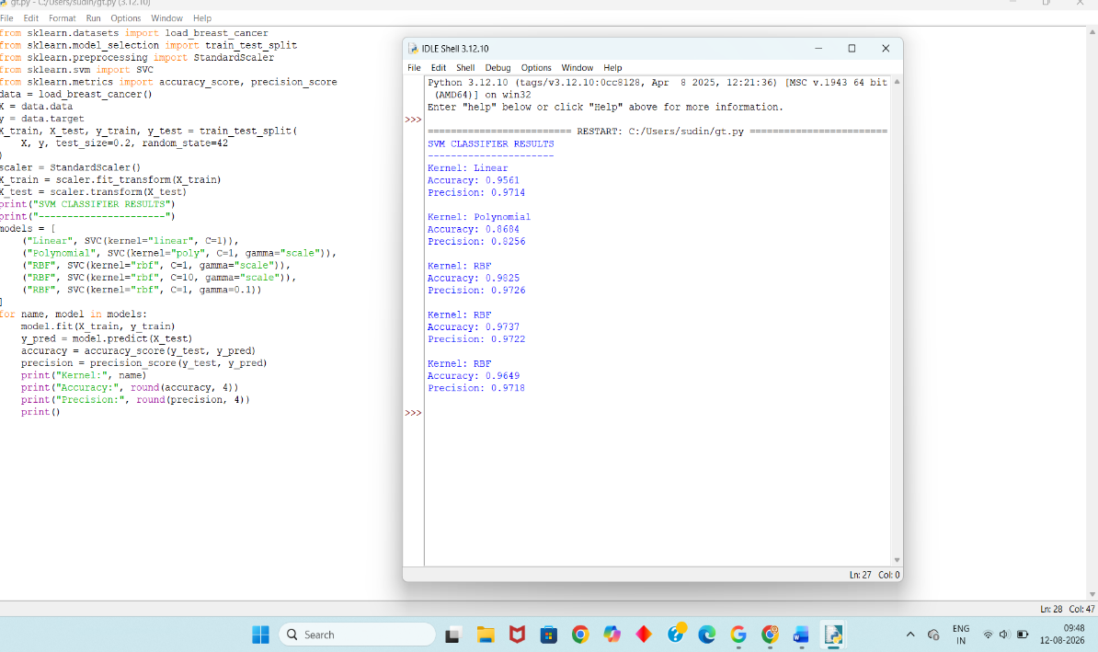
Result: The SVM classifier successfully classified the Breast Cancer dataset. The results demonstrate that kernel selection and parameters such as C and gamma affect the accuracy and precision of the model.
EXP 4 – K-MEANS CLUSTERING
Aim: To implement the K-Means clustering algorithm on an unlabeled dataset and evaluate clustering quality using inertia and silhouette score for different numbers of clusters.
Problem Statement:
Implement K-Means clustering using the Wine dataset without using its class labels. Vary the number of clusters from 2 to 6 and calculate inertia and silhouette scores. Analyze the effect of the number of clusters and feature scaling on clustering performance.
Python Code:
from sklearn.datasets import load_wine
from sklearn.preprocessing import StandardScaler
from sklearn.cluster import KMeans
from sklearn.metrics import silhouette_score
data = load_wine()
X = data.data
scaler = StandardScaler()
X_scaled = scaler.fit_transform(X)
print("K-MEANS CLUSTERING RESULTS")
print("--------------------------")
for k in range(2, 7):
model = KMeans(
n_clusters=k,
init="k-means++",
random_state=42,
n_init=10
)
labels = model.fit_predict(X_scaled)
inertia = model.inertia_
silhouette = silhouette_score(X_scaled, labels)
print("Number of Clusters:", k)
print("Inertia:", round(inertia, 2))
print("Silhouette Score:", round(silhouette, 4))
print()
Output:
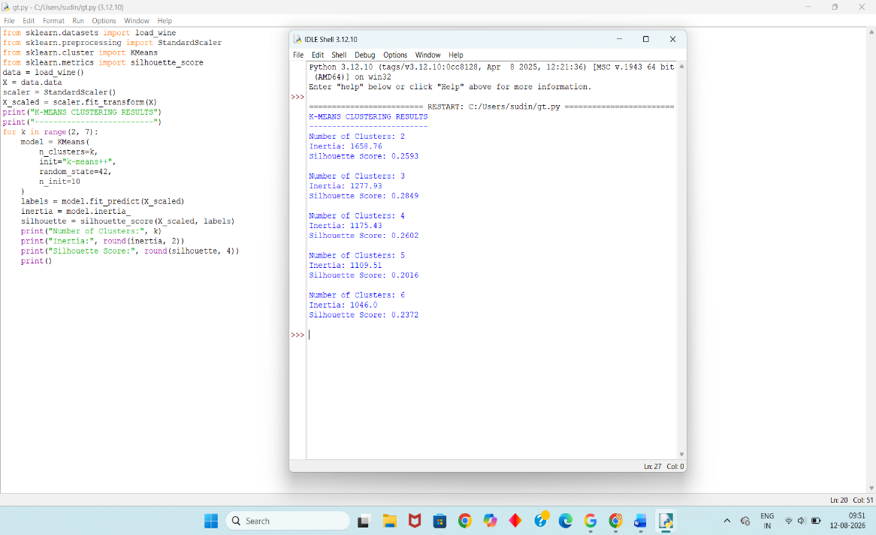
Result: K-Means successfully grouped the Wine dataset into different clusters. Inertia decreases as the number of clusters increases, while the silhouette score helps identify the quality of cluster separation. In this experiment, 3 clusters provide a comparatively better silhouette score.

EXP 5 – LOGISTIC REGRESSION
Aim: To implement a Logistic Regression model for binary classification and compare the performance of L1 and L2 regularization using accuracy, precision, and recall.

Problem Statement:
Implement Logistic Regression on the Breast Cancer dataset. Train the model using L1 and L2 regularization and compare their classification performance using accuracy, precision, and recall. Analyze how regularization affects model complexity and generalization.
Python Code:
from sklearn.datasets import load_breast_cancer
from sklearn.model_selection import train_test_split
from sklearn.preprocessing import StandardScaler
from sklearn.linear_model import LogisticRegression
from sklearn.metrics import accuracy_score, precision_score, recall_score
data = load_breast_cancer()
X = data.data
y = data.target
X_train, X_test, y_train, y_test = train_test_split(
X, y, test_size=0.2, random_state=42
)
scaler = StandardScaler()
X_train = scaler.fit_transform(X_train)
X_test = scaler.transform(X_test)
print("LOGISTIC REGRESSION RESULTS")
print("---------------------------")
l1_model = LogisticRegression(
l1_ratio=1,
C=1,
solver="saga",
max_iter=5000
)
l1_model.fit(X_train, y_train)
y_pred = l1_model.predict(X_test)
print("Model: L1 Regularization")
print("Accuracy:", round(accuracy_score(y_test, y_pred), 4))
print("Precision:", round(precision_score(y_test, y_pred), 4))
print("Recall:", round(recall_score(y_test, y_pred), 4))
print()
l2_model = LogisticRegression(
l1_ratio=0,
C=1,
solver="saga",
max_iter=5000
)
l2_model.fit(X_train, y_train)
y_pred = l2_model.predict(X_test)
print("Model: L2 Regularization")
print("Accuracy:", round(accuracy_score(y_test, y_pred), 4))
print("Precision:", round(precision_score(y_test, y_pred), 4))
print("Recall:", round(recall_score(y_test, y_pred), 4))
Output:
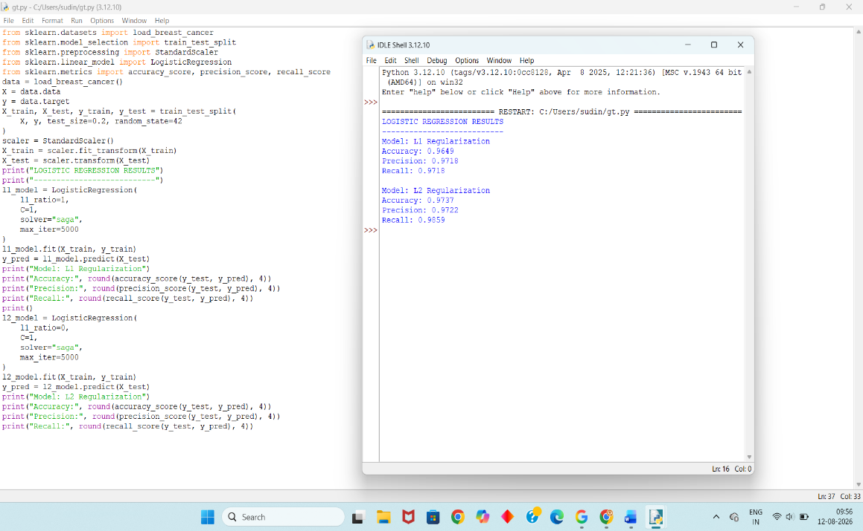
Result: Logistic Regression successfully performed binary classification on the Breast Cancer dataset. Both L1 and L2 regularization produced high classification performance. Regularization helps control model complexity and reduces the possibility of overfitting.

RUBRICS FOR CALCULATION

Criteria | Weightage | Level 4 – Exemplary (5 Marks) | Level 3 – Proficient (4 Marks) | Level 2 – Developing (2–3 Marks) | Level 1 – Beginning (0–1 Mark)
Conceptual Understanding | 30 | Demonstrates clear and complete understanding of the concept | Good understanding with minor gaps | Basic understanding with some misconceptions | Poor or incorrect understanding
Accuracy of Answer | 25 | Completely correct answer with no errors | Mostly correct with minor errors | Partially correct with noticeable errors | Incorrect or irrelevant answer
Application of Knowledge | 15 | Correctly applies concepts to solve the question/problem | Applies concepts with minor mistakes | Limited or partially correct application | No or incorrect application
Completeness of Response | 15 | Covers all required parts of the question | Covers most parts with minor omissions | Covers only some parts | Incomplete or missing response
Clarity & Presentation | 15 | Clear, concise, and well-organized answer | Understandable with minor issues | Somewhat unclear or poorly structured | Difficult to understand

